TOWN BOARD DISCUSSION AGENDA
MARCH 8, 2022

https://www.youtube.com/live/gMU_yVyvAaU?si=DaJ1_qMmGfG8flnr
Carpenter voted for
#17 mullen. #18 tried mullen. #24-27 spoke for all with vote
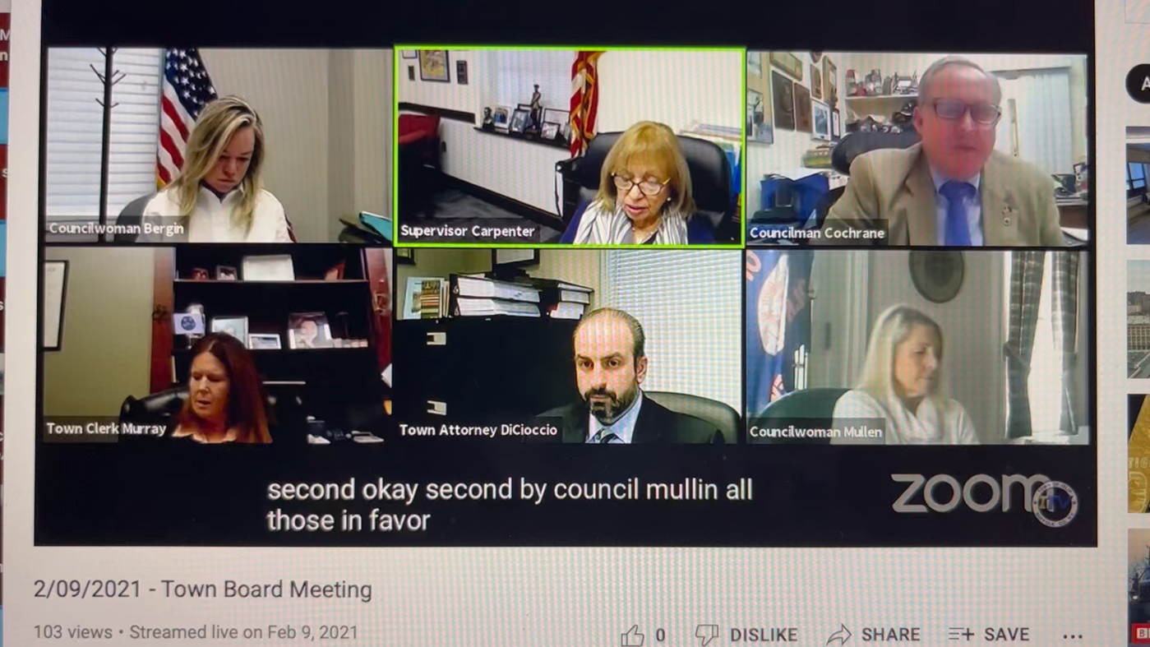
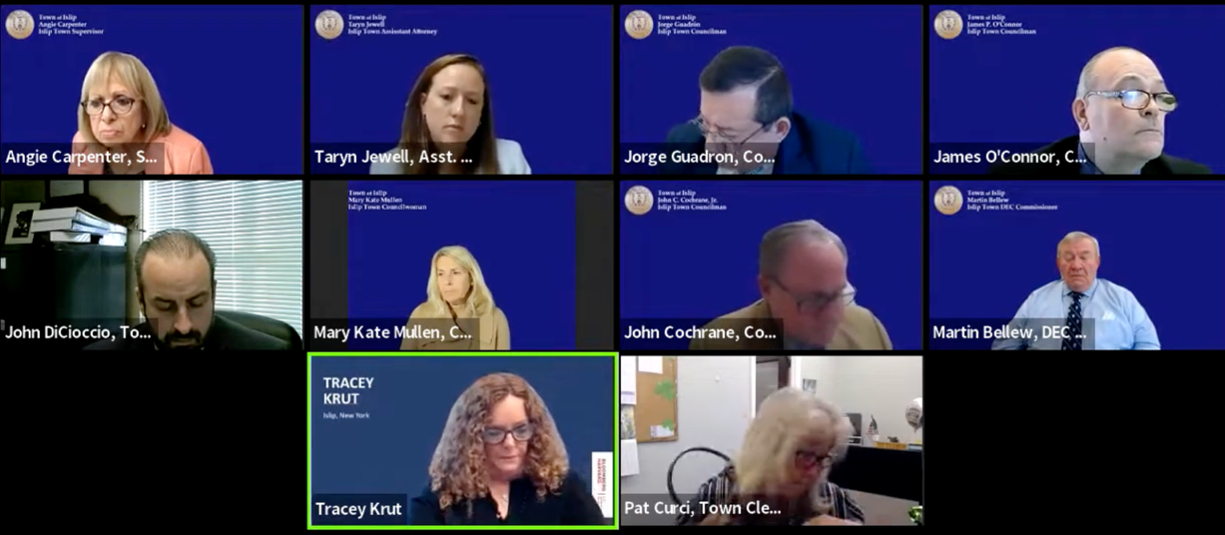
https://www.youtube.com/live/gcyw9E3vLW8?si=zMVyJ-RLpP2xTwRL
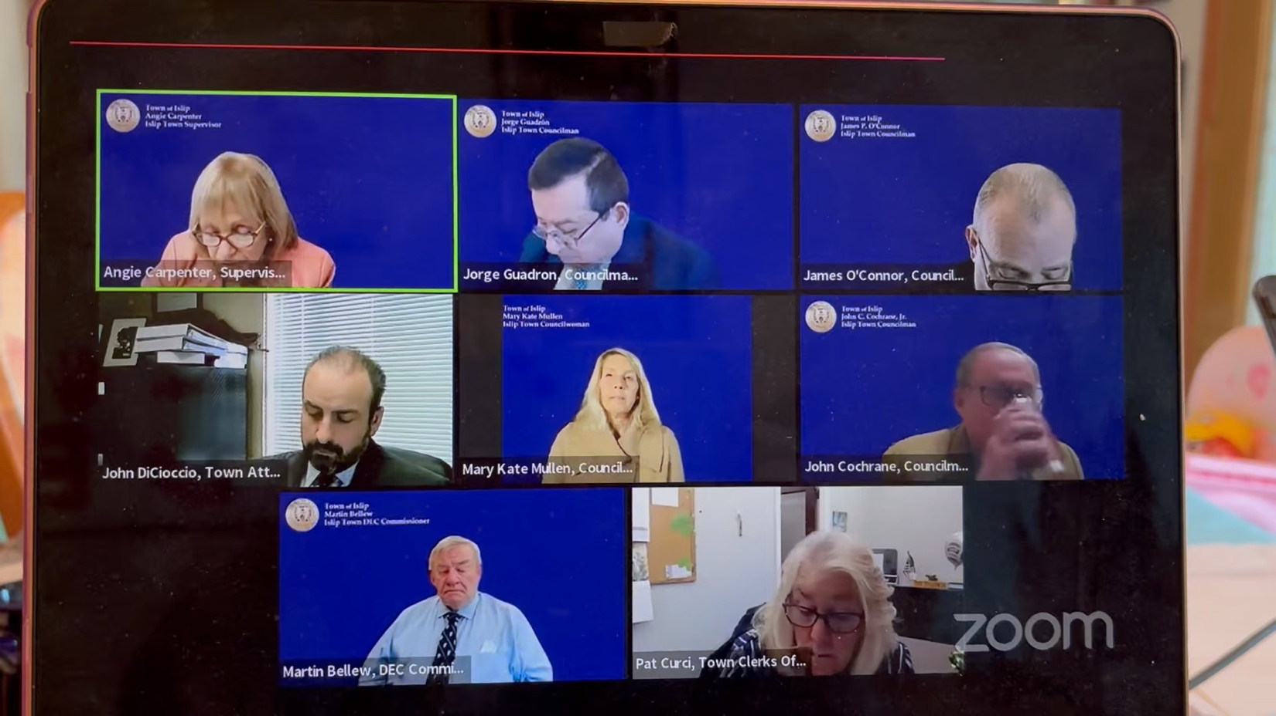

https://www.youtube.com/live/gMU_yVyvAaU?si=W3G6eYx-ZzZnPjlk
Voted for all 4 council

You can also click on the picture
These are samples of some, there are over 100 videos where the Supervisor votes what she wants

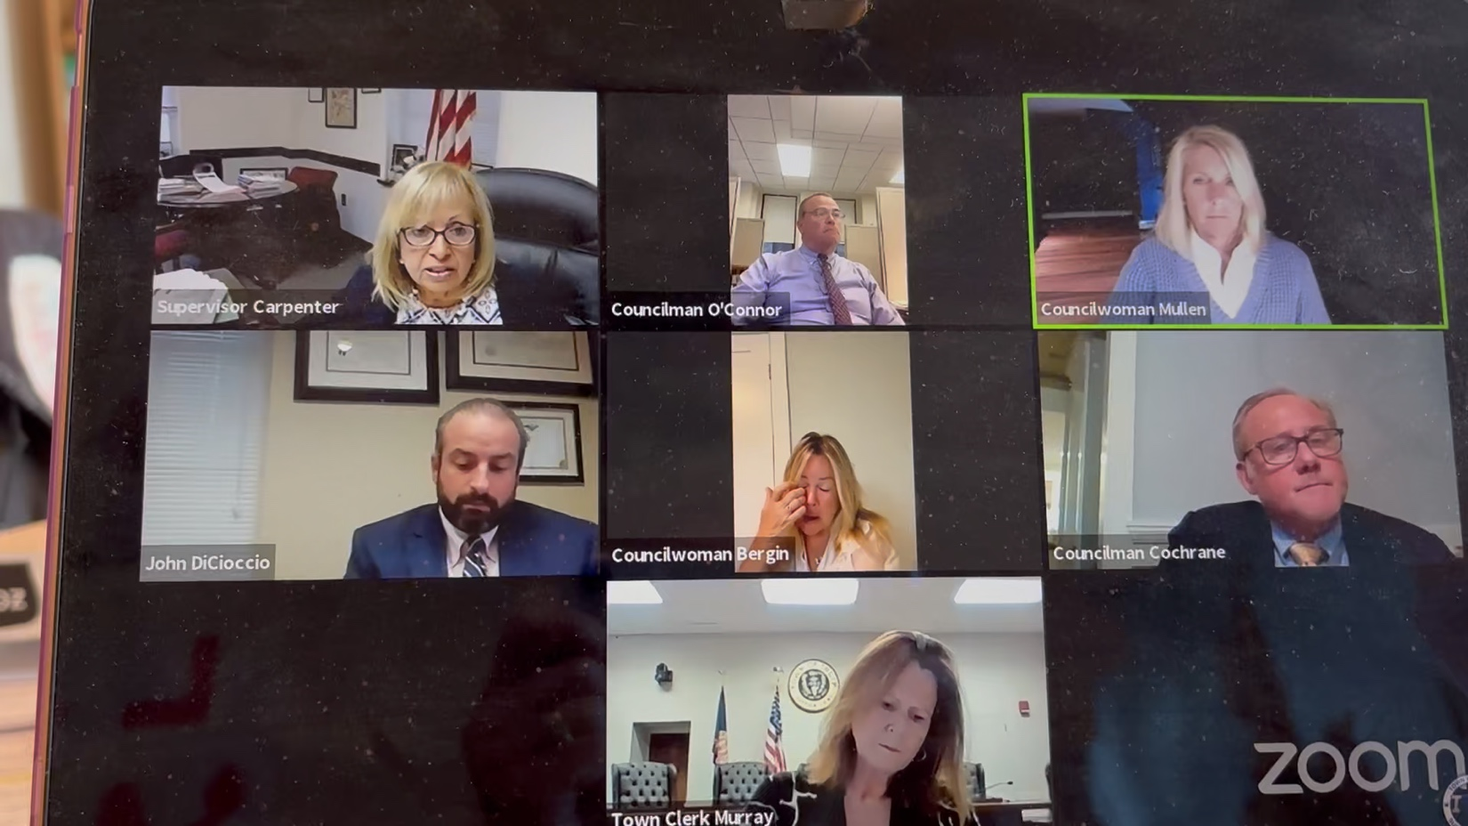

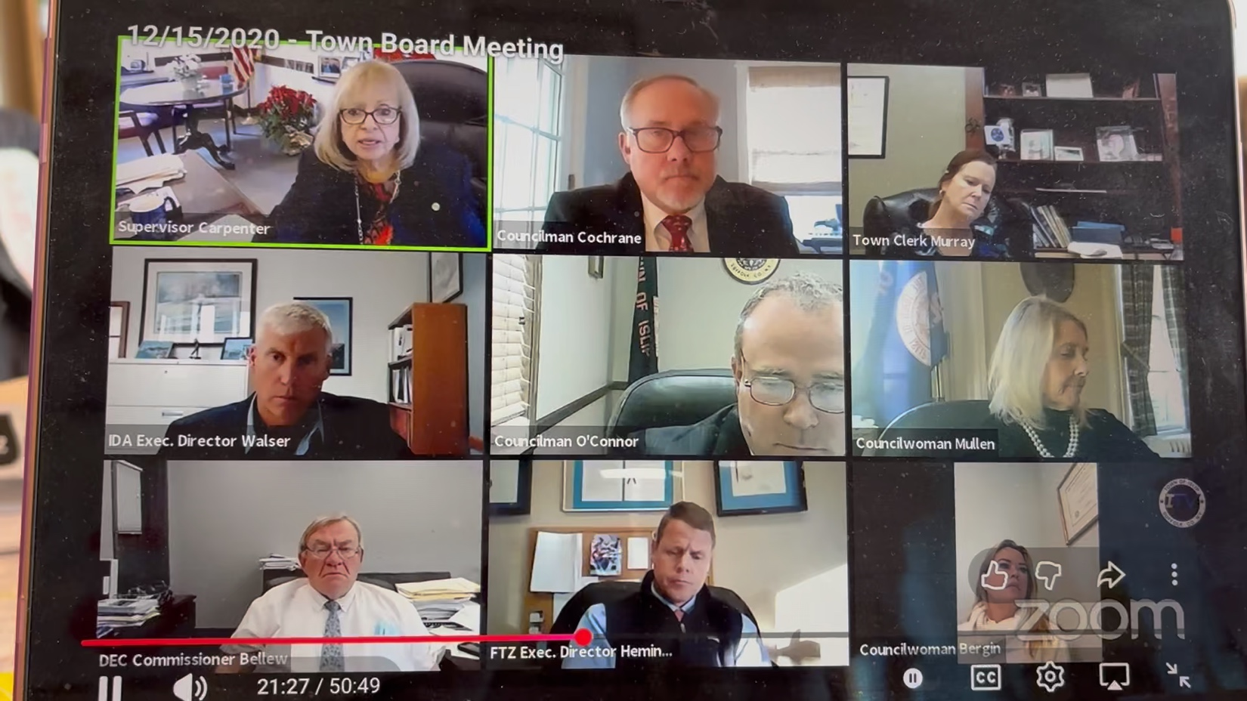
Supervisor Voted for Cochrane
Voted for O’Connor, Mullen Bergin Cochran
https://www.youtube.com/live/-YjLAjekPQE?si=j8--IV-p6BDz79Hn

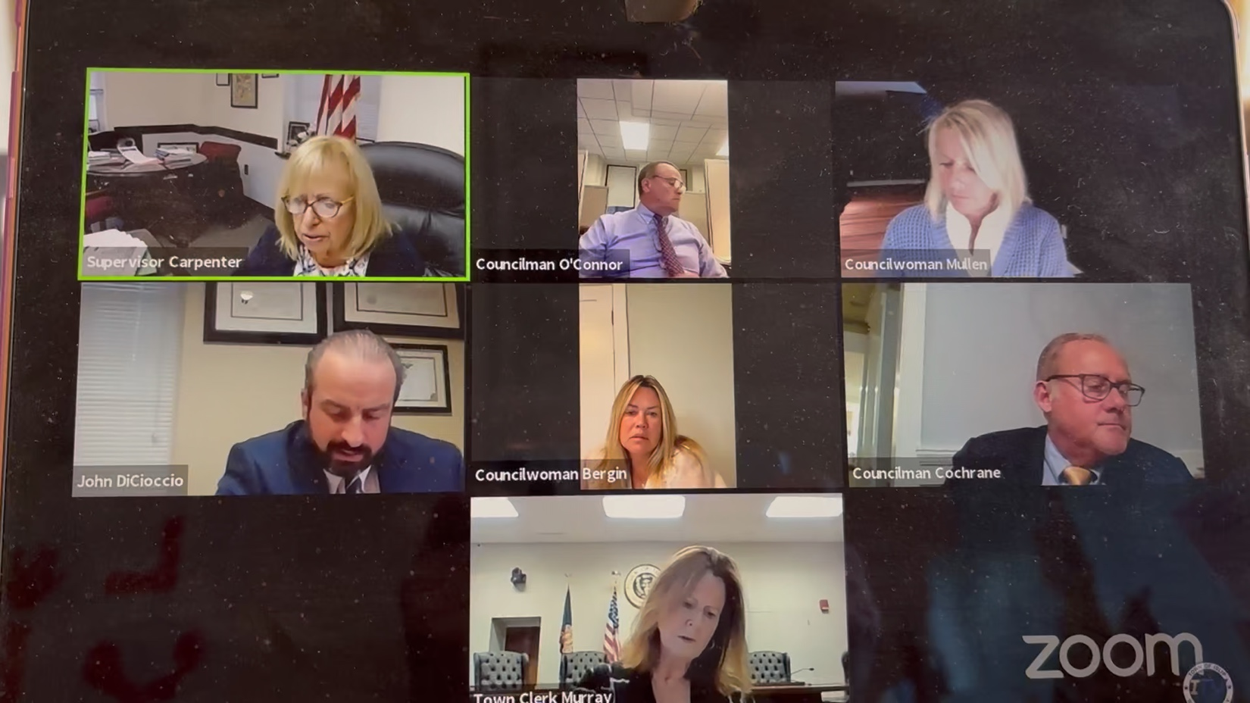

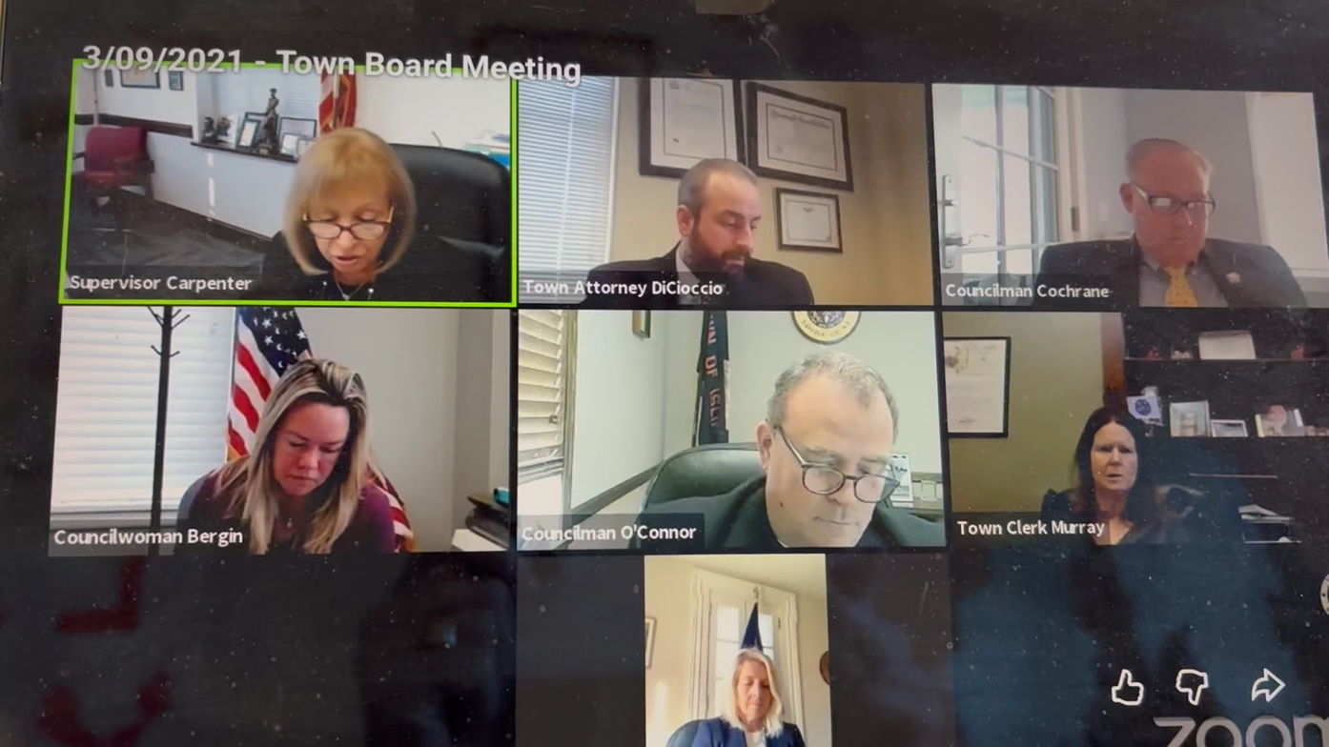
Supervisor voted for Cochran

https://www.youtube.com/live/RMohFvWgfKI?si=9ImzD5KuokQpZVgp Supervisor voted for O’Connor

